

CEG 4136 Computer Architecture III: FINAL EXAM

Date: December 4th | Professor: Dr. M. Bolic
Duration: 3 hours | Session: Fall 2014-2015
Total Points = 100 out of avalable 106

Note: Closed book exam. Calculators are not allowed.

Name: _______________________Student ID:_______________

Question | Maximum | Score
1 | 24
2 | 12
3 | 15
4 | 12
5 | 14
6 | 20
7 | 9
Total | 106
QUESTION #1 (4 points each, total 24)

Define, compare and comment on the following (within 2-4 sentences each):
- How many stages of 4x4 switches are needed for 16x16 multistage network? What is the total number of 4x4 switches needed?

- Consider a multiprocessor system with 2 processors (A and B) with their individual caches that are connected via a bus with a shared memory. Variable x is originally x=3. Given is the following sequence of operations:
1. A reads variable x
2. B reads variable x
3. B updates x so that x=x+2
4. A updates x so that x=x*2
5. B reads variable x
What will processor B read in step 5 if no cache coherence mechanism is implemented?

- What techniques/transactions can be used for the buses where fast and slow devices need to communicate? List at least 2.

- What is the split-transaction bus? Why is it used? What changes in the system does one need to make in order to support split transaction buses?

- What is the information that has to be exchanged between two caches (L1 and L2) for the snooping protocol with multilevel caches? Assume that the caches are inclusive. Describe information exchange in both L1->L2 and L2->L1 directions.

- What is the purpose of wired-NOR bus line in the MESI protocol? Why is there a shared signal line between caches? How is this line implemented?
QUESTION #2 (4 points each, total 12)
Consider a shared memory system with two processors.
- What value will processor P1 print?
- If variable flag is used only in this portion of the code of processors P1 and P2, do we need to use lock (mutex)? Do we need to use lock for variable A?
- System deadlock refers to a situation in a multiprocessor system when concurrent processes are holding resources and preventing each other from completing their execution. Is it possible that this software causes deadlock situation?

P1 | P2
….  A=0;  while (flag==0) do nothing;  print A;  … | …  A=1;  flag=1;  …

QUESTION #3: (a 7 points, b, c 4 points each, total 15 points)
Figure below shows the Store and Forwarding and Cut-Through routing situations where 4-flit packet traverses three hops from source to destination. Each node in Store and Forward routing can buffer 4 flits. Intermediate nodes in Cut-Through routing can buffer only one flit.
- Fill the table below to show what flit is in what node in each cycle. In the end, all 4 flits need to be in the destination node. State all your assumptions clearly. Which routing is faster and why?
- Is it possible that the packet occupies all the nodes in cut-through routing? If yes, how is then different from circuit switching.
- Write the formula for the communication delays in Store and Forwarding and Cut-Through routing networks when the packet has M flits and traverses N nodes.

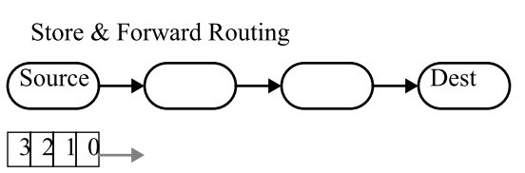 | 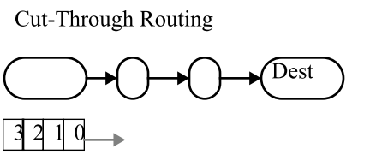
  Cycle | Source node | Intermediate node 1 | Intermediate node 2 | Destination node
   | 3,2,1,0
   | 3,2,1 | 0
  Cycle | Source node | Intermediate node 1 | Intermediate node 2 | Destination node
   | 3,2,1,0
   | 3,2,1 | 0
QUESTION #4: (4 points each, total 12 points)

Let us consider bidirectional ring network with 4 nodes. Each node contains a router as shown in figure below with 2 virtual buffers per input port.
- How many inputs and output ports in switches in each node do we need to use?
- Show how you would use virtual buffers to avoid deadlocks when sending messages in this ring network.
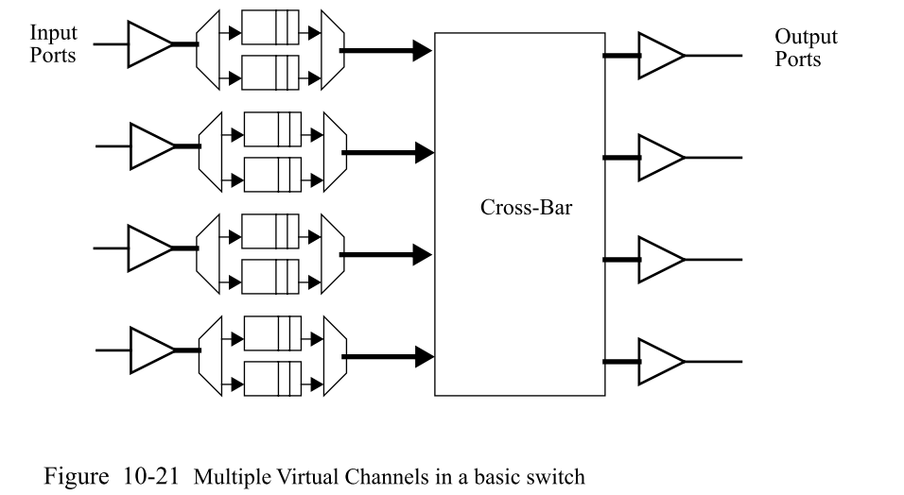

- Is it possible to implement the crossbar like in a figure below? Why/why not. What is the name and the function of the component would generate the control signals for multiplexers in the router?
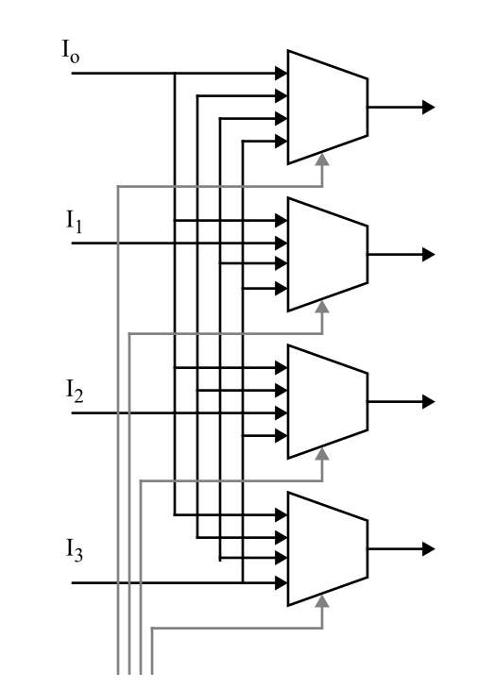

QUESTION #5 (7 points each, total 14 points)

- Figure below shows threads running on different functional units at each clock cycle. Name 3 types of processors on which these threads are running? What are possible reasons for empty slots in each of these examples?
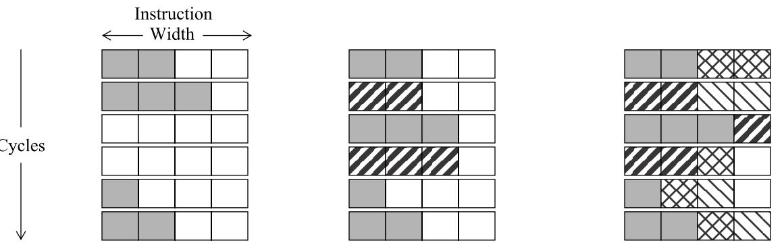

- Calculate speed-up of interleaved multithreaded implementation on a multithreaded RISC processor that execute threads T1 up to T6 shown in figure below vs. implementation without threads (all the code is executed sequentially). Interleaved multithreading implementation is intelligent so that when, for example, thread T1 does not have instruction ready the processor will execute the instruction from the next ready thread in the same clock cycle.
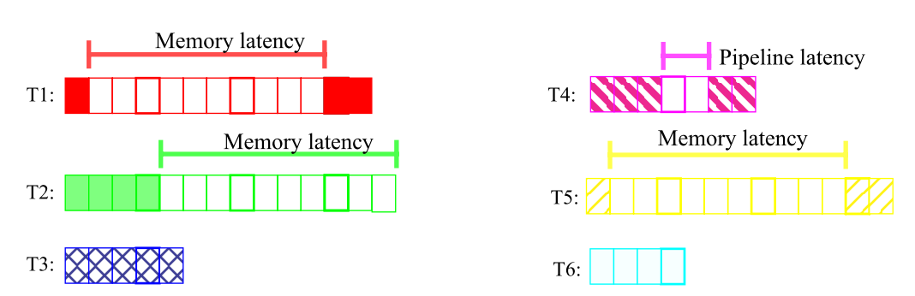

QUESTION #6 (total 20 points)

The following routine implements T&S using LL and SC commands.
T&S(Rx,lock): ADDI R1,R0,1 / Sets R1 to 1
LL Rx,lock / Load linked variable lock to Rx
SC R1,lock / Store conditionally R1 to lock. If SC fails, it does not write / to the memory but only sets R1 to 0
BEQZ R1, T&S / If R1 is zero, go back to T&S
RET

Consider a shared memory system with level one cache running MSI protocol. Assume that 3 processors are running T&S lock routine at the same time. Assume that processor P1 got the lock first as shown in table below (wrote successfully 1 into variable lock). Fill the table based on different actions taken by processors.

Actions | Cache 1 for var. lock | Status of Cache 1 for var. lock | Cache 2 for var. lock | Status of Cache 2 for var. lock | Cache 3 for var. lock | Status of Cache 3 for var. lock | Memory  var. lock
Initially |  | I |  | I |  | I | 0
P1 successful lock (lock =1) | 1 | M
P2 LL command
P2 SC command
P3 LL command
P3 SC command
P2 LL command
P1 unlock lock (lock=0)
P2 SC command
P3 LL command
P3 SC command

QUESTION #7 (total 9 points)

How long would the following instructions take to execute on an in-order superscalar processor with two execution units, where each execution unit can execute any operation. Latency of the execution stage of load operation is 3 cycles, and all other operations have latency of 2 cycles. Assume that processor has a 6 stage pipeline.

LD r4, (r5)
LD r7, (r8)
ADD r9, r4, r7
LD r10, (r11)
Mul r12, r13, r14
SUB r2, r3, r1
ST (r2), r15
MUL r21, r4, r7
ST (r22), r23
ST (r24), r21

